We start with basic nmap to reveal open ports and services running on those ports.
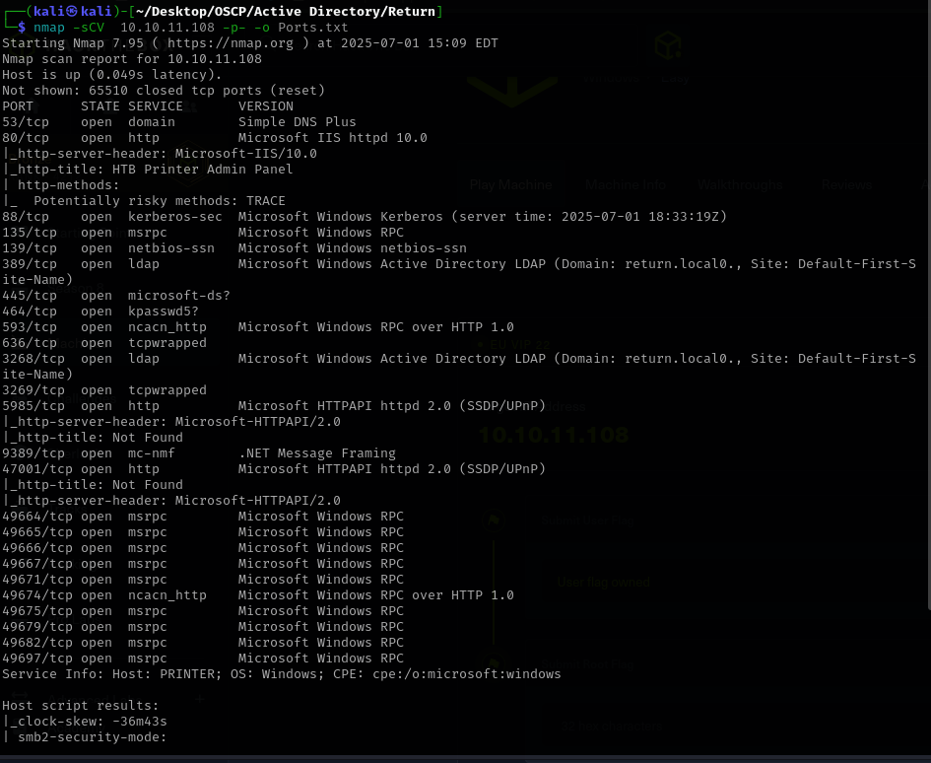
We have an open port 80 which means a webapp
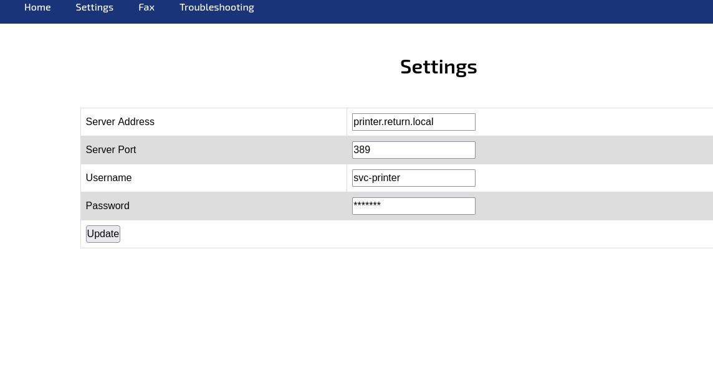

The setting page gives us an username and also let’s us ip address.
Starting a netcat listener and leaving the port 389 gave us a password.
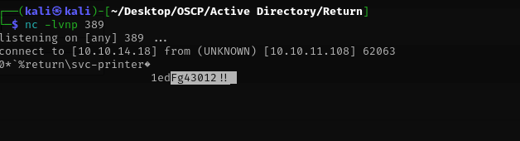
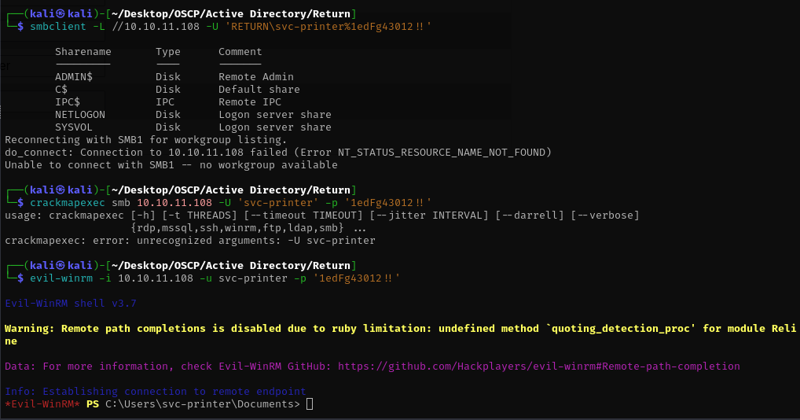
We enumerated the shares and got a shell with Evil-winrm which gave us the user.txt flag.
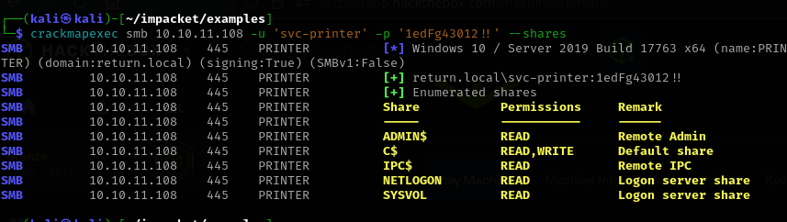
I’ve also enumerated what shares I have access to, maybe usefull for privilege escalation.
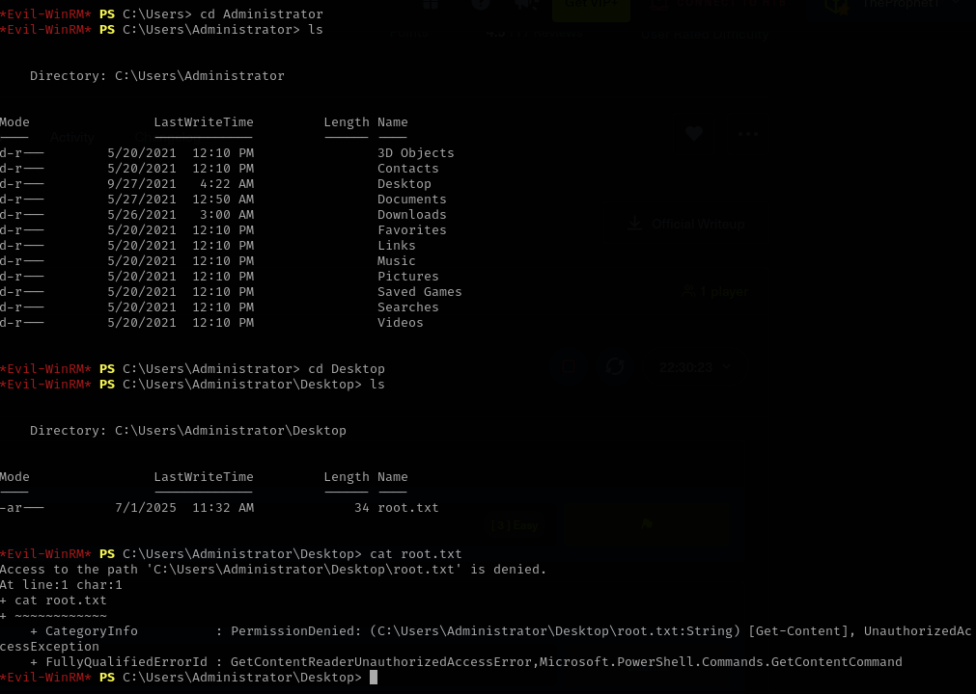
I can access the Administrator /directory but can’t cat root.txt.
I wanted to try winpeas on the vulnerable machine so I started a server on the directory where I had winpeas and tried to get it on the vulnerable machine
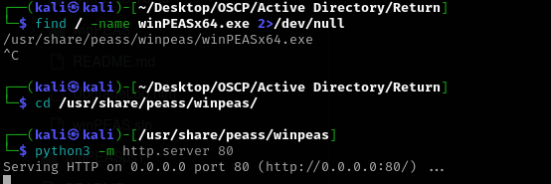

And it worked
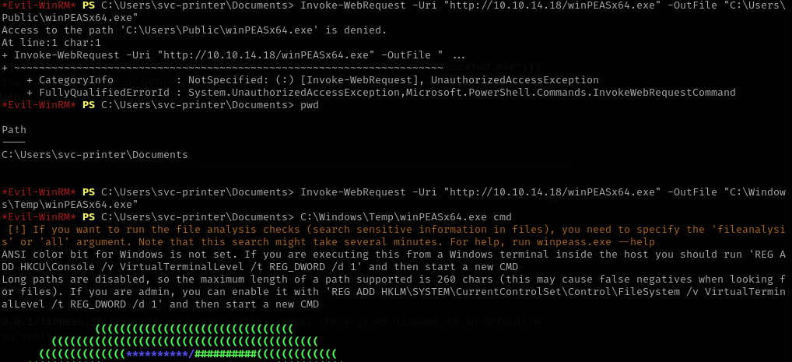
The output revelead that we can stop services as server operators group.
Members of this group can start/stop system services. Let's modify a service binary path to obtain a reverse shell.
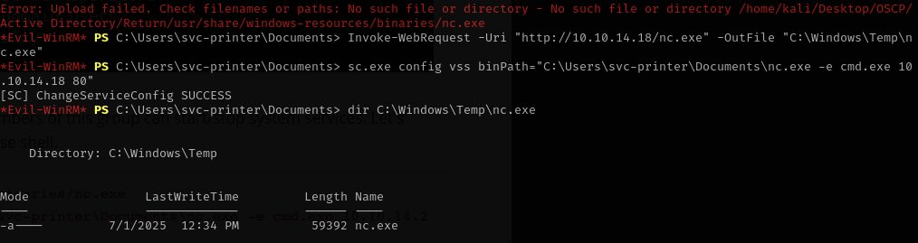
I uploaded nc.exe then modified the binaries to connect to my attacking machine.
Started vss and gained shell as root.
